Help documnet for verification of Numerical Account for A52 and AA 52
- Select Fixed Assets Monitoring under Financial Accounting
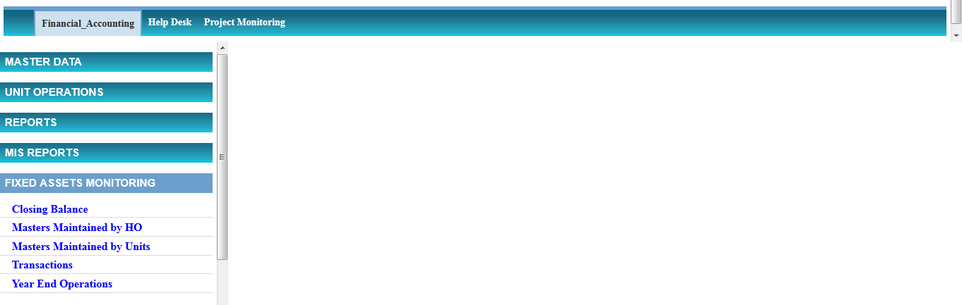
- Select Closing Balance
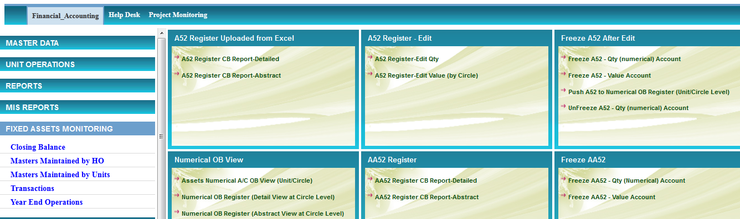

A52 Numerical Verification

- Select A52 Register CB Report- Detailed
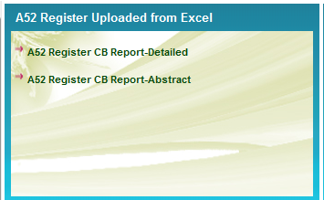
- Select the following Options and press submit
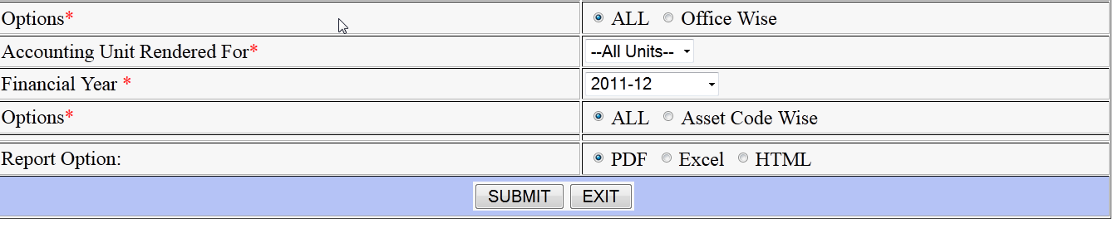

- Check the report displayed for your office either by taking the print out or verifying in the screen against the numerical register. Sample report is pasted below
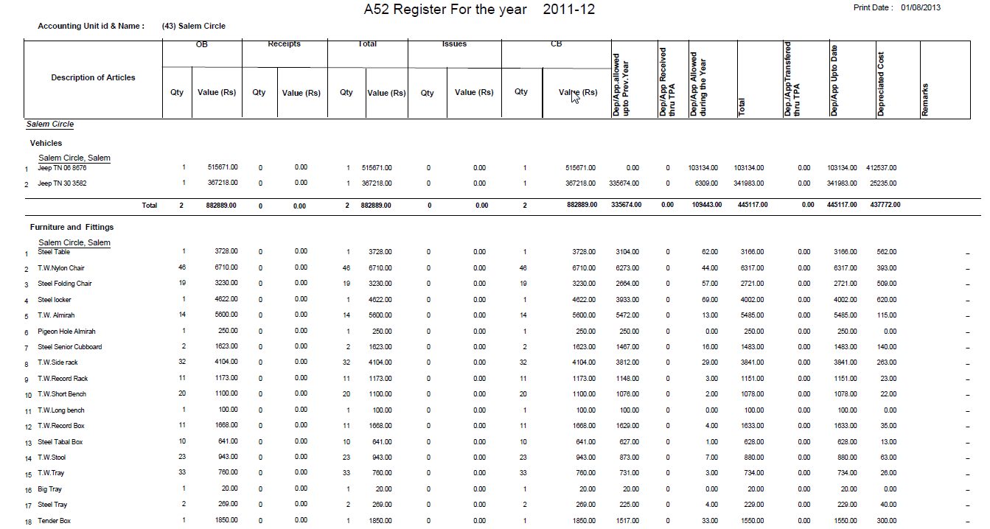
- If there is any problem, like entries in one or more columns are missing or some records are missed out please give help desk or send mail to twadboard@dataone.in
- If the uploading is correct, please freeze the numerical account by selecting the following
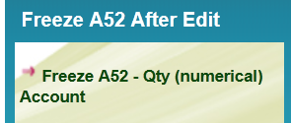

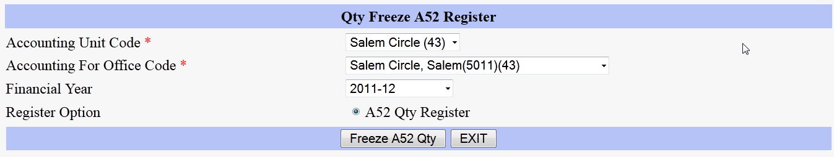

and press Freeze A52 Qty.

AA52 Numerical verification

- Select AA52 Register CB Report- Detailed
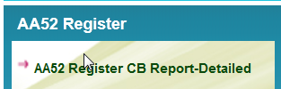

- Select the following Options and press submit

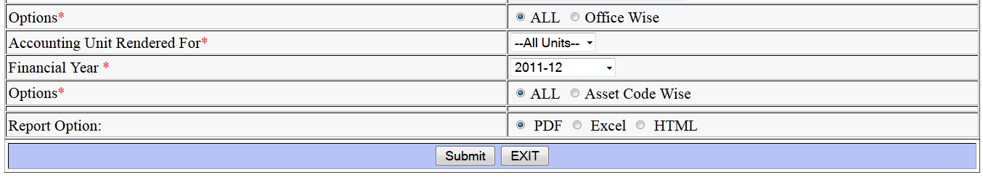

- Check the report displayed for your office either by taking the print out or verifying in the screen against the Discarded Asset register. Sample report is pasted below

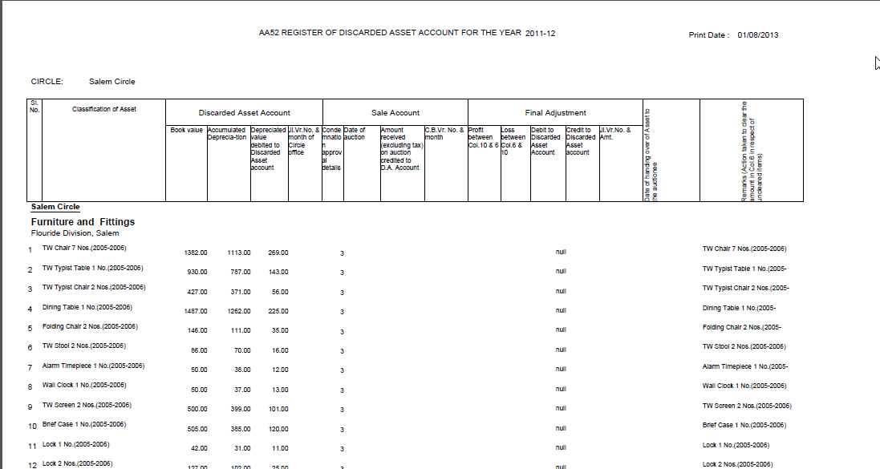

If there is any problem, like entries in one or more columns are missing or some records are missed out please give help desk or send mail to twadboard@dataone.in
- If the uploading is correct, please freeze the Discarded numerical account by selecting the following
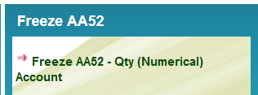
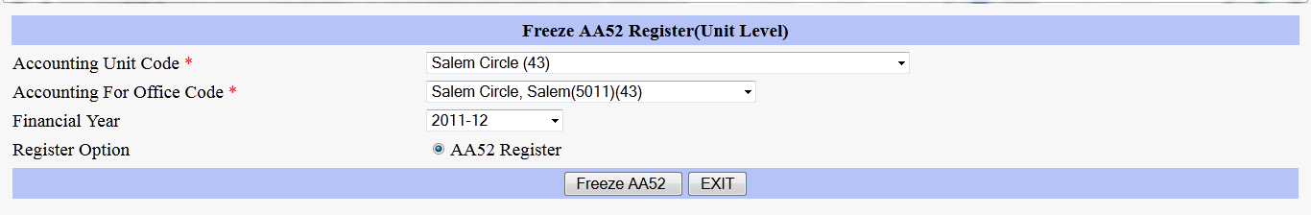

And press Freeze AA52 Register .

